**What is Cloud Computing**

The term cloud refers to a network or the internet. It is a technology that uses remote servers on the internet to store, manage, and access data online rather than local drives. The data can be anything such as files, images, documents, audio, video, and more.

There are the following operations that we can do using cloud computing:

* Developing new applications and services
* Storage, back up, and recovery of data
* Hosting blogs and websites
* Delivery of software on demand
* Analysis of data
* Streaming videos and audios

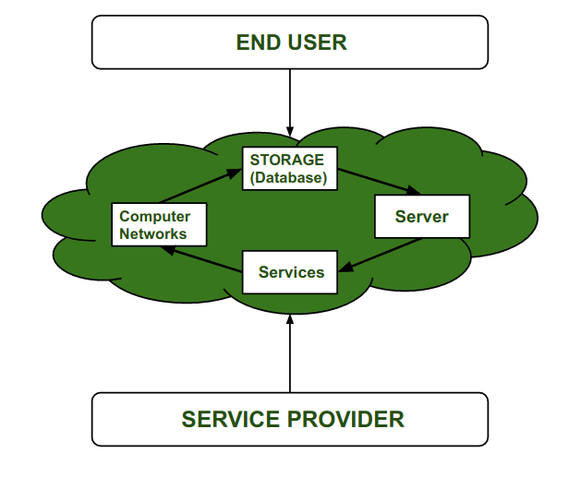

## Why Cloud Computing?

Small as well as large IT companies, follow the traditional methods to provide the IT infrastructure. That means **for any IT company, we need a Server Room that is the basic need of IT companies**.

In that server room, there should be a database server, mail server, networking, firewalls, routers, modem, switches, QPS (Query Per Second means how much queries or load will be handled by the server), configurable system, high net speed, and the maintenance engineers.

To establish such IT infrastructure, we need to spend lots of money. To overcome all these problems and to reduce the IT infrastructure cost, Cloud Computing comes into existence.

## Cloud Computing

## Characteristics of Cloud Computing

The characteristics of cloud computing are given below:

**1) Agility**

The cloud **works in a distributed computing environment**. It shares resources among users and works very fast.

**2) High availability and reliability**

The availability of servers is high and more reliable because the **chances of infrastructure failure are minimum**.

**3) High Scalability**

Cloud offers **"on-demand" provisioning of resources on a large scale**, without having engineers for peak loads.

**4) Multi-Sharing**

With the help of cloud computing, **multiple users and applications can work more efficiently** with cost reductions by sharing common infrastructure.

**5) Device and Location Independence**

Cloud computing enables the users to access systems using a web browser regardless of their location or what device they use e.g. PC, mobile phone, etc. **As infrastructure is off-site** (typically provided by a third-party) **and accessed via the Internet, users can connect from anywhere**.

**6) Maintenance**

Maintenance of cloud computing applications is easier, since they **do not need to be installed on each user's computer and can be accessed from different places**. So, it reduces the cost also.

**7) Low Cost**

By using cloud computing, the cost will be reduced because to take the services of cloud computing, **IT company need not to set its own infrastructure** and pay-as-per usage of resources.

**8) Services in the pay-per-use mode**

Application Programming Interfaces**(APIs) are provided to the users so that they can access services on the cloud** by using these APIs **and pay the charges as per the usage of services**.

**History of Cloud Computing :**  
In this, we will discuss the history of Cloud computing. And also cover the history of client server computing, distributed computing, and cloud computing.

* Before Computing was come into existence, client Server Architecture was used where all the data and control of client resides in Server side. If a single user want to access some data, firstly user need to connect to the server and after that user will get appropriate access. But it has many disadvantages. So, After Client Server computing, Distributed Computing was come into existence, in this type of computing all computers are networked together with the help of this, user can share their resources when needed. It also has certain limitations. So in order to remove limitations faced in distributed system, cloud computing was emerged.

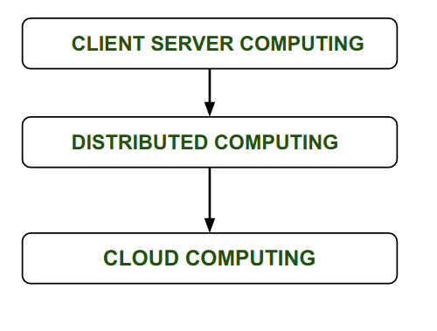

# **Cloud Computing Challenges**

Cloud computing, an emergent technology, has placed many challenges in different aspects of data and information handling. Some of these are shown in the following diagram:

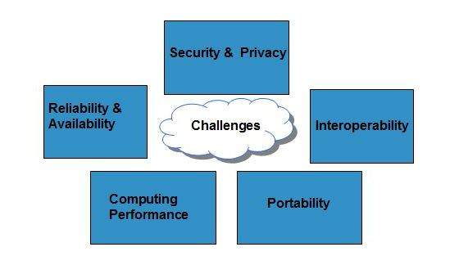

Security and Privacy

Security and Privacy of information is the biggest challenge to cloud computing. Security and privacy issues can be overcome by employing encryption, security hardware and security applications.

Portability

This is another challenge to cloud computing that applications should easily be migrated from one cloud provider to another. There must not be vendor lock-in. However, it is not yet made possible because each of the cloud provider uses different standard languages for their platforms.

Interoperability

It means the application on one platform should be able to incorporate services from the other platforms. It is made possible via web services, but developing such web services is very complex.

Computing Performance

Data intensive applications on cloud requires high network bandwidth, which results in high cost. Low bandwidth does not meet the desired computing performance of cloud application.

Reliability and Availability

It is necessary for cloud systems to be reliable and robust because most of the businesses are now becoming dependent on services provided by third-party.

**Vision Of Cloud Computing**

In Simplest terms, [cloud computing](https://www.geeksforgeeks.org/cloud-computing/) means storing and accessing the data and programs on remote servers that are hosted on internet instead of computer’s hard drive or local server. Cloud computing is also referred as Internet based computing. These are following **Vision of Cloud Computing :**

1. Cloud computing provides the facility to provision virtual hardware, runtime environment and services to a person having money.
2. These all things can be used as long as they are needed by the user.
3. The whole collection of computing system is transformed into collection of utilities, which can be provisioned and composed together to deploy systems in hours rather than days, with no maintenance cost.
4. The long term vision of a cloud computing is that IT services are traded as utilities in an open market without technological and legal barriers.
5. In the future, we can imagine that it will be possible to find the solution that matches with our requirements by simply entering out request in a global digital market that trades with cloud computing services.
6. The existence of such market will enable the automation of discovery process and its integration into its existing software systems.
7. Due to the existence of a global platform for trading cloud services will also help service providers to potentially increase their revenue.
8. A cloud provider can also become a consumer of a competition service in order to fulfill its promises to customers.
9. In the near future we can imagine a solution that suits our needs by simply applying our application to the global digital market for cloud computing services.
10. The presence of this market will enable the acquisition process to automatically integrate with its integration into its existing software applications. The availability of a global cloud trading platform will also help service providers to increase their revenue.
11. A cloud provider can also be a buyer of a competitive service to fulfill its promises to customers.

**Driving Factors Towards cloud**

There are several driving factors that have led to the widespread adoption of cloud computing. Some of these factors include:

1. Scalability: Cloud computing allows businesses to quickly and easily scale their computing resources up or down as needed, without having to invest in new hardware or infrastructure. This makes it easier for businesses to adapt to changing demands and to grow or shrink their operations as needed.
2. Cost-effectiveness: Using cloud computing services can be more cost-effective than investing in on-premises infrastructure. Cloud providers often offer pay-as-you-go pricing models, allowing businesses to only pay for the resources they use. Additionally, cloud services eliminate the need for businesses to purchase and maintain their own hardware and software, which can be a significant cost savings.
3. Accessibility: Cloud computing services can be accessed from anywhere with an internet connection, which makes it easier for businesses to provide their employees with remote access to critical applications and data.
4. Flexibility: Cloud computing services offer a high degree of flexibility, allowing businesses to choose the specific services and features they need. This can be especially beneficial for businesses with unique or specialized needs.
5. Reliability: Cloud providers typically offer high levels of reliability and uptime, which can be difficult for businesses to achieve on their own. This can help ensure that critical applications and data are always available when they are needed.

Overall, these factors, along with others, have made cloud computing an attractive option for businesses of all sizes and industries, driving its widespread adoption in recent years.

**Grid Computing**

Grid computing is a form of distributed computing that involves sharing computing resources across multiple geographically dispersed locations. In grid computing, individual computers or clusters of computers are connected together over a network, and each computer contributes its processing power and storage capacity to a shared pool of resources.

Cloud computing, on the other hand, is a model of computing in which users access computing resources over the internet on an on-demand basis. Cloud computing typically involves the use of virtualized computing resources, such as virtual servers, storage, and networking, that are provided by a cloud service provider.

While there are some similarities between grid computing and cloud computing, such as the use of distributed computing and resource sharing, there are also some important differences. Grid computing typically involves the use of specialized middleware and protocols to manage the distributed computing resources, while cloud computing relies on virtualization technology and service-level agreements (SLAs) to provide users with access to computing resources.

In general, cloud computing is more flexible and scalable than grid computing, as it allows users to quickly and easily provision and de-provision computing resources as needed. Additionally, cloud computing provides users with greater control and visibility over their computing resources, as well as the ability to pay only for what they use.

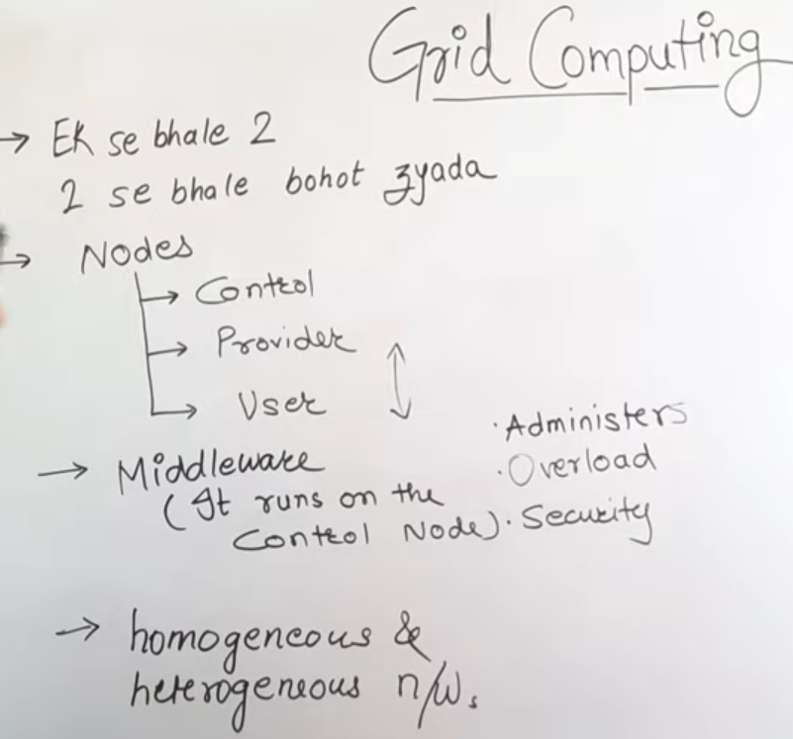

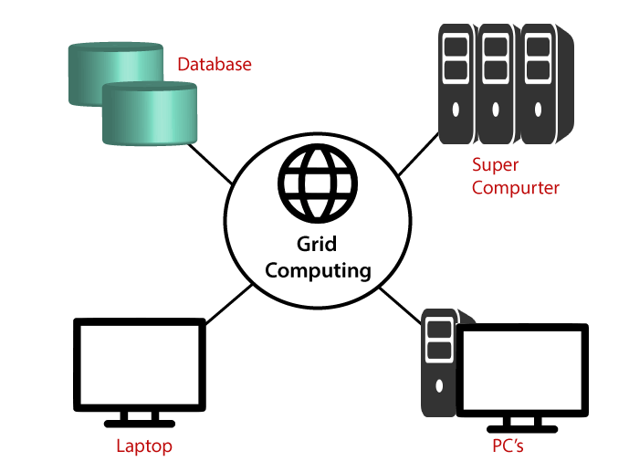

**Utility Computing**

Utility computing is a model of cloud computing in which computing resources, such as processing power, storage, and bandwidth, are provided to users on an as-needed basis, much like a public utility. In this model, users pay for the resources they consume, much like how they would pay for electricity or water.

In utility computing, the cloud service provider manages the underlying infrastructure, including servers, storage, and network components, and users only need to worry about their own applications and data. This makes it easier and more cost-effective for organizations to scale up or down their computing resources as needed, without having to invest in and manage their own hardware.

The utility computing model can also provide greater flexibility and agility to organizations, allowing them to quickly respond to changing business requirements or market conditions. Additionally, because users only pay for the resources they consume, it can be a cost-effective solution for organizations that have variable or unpredictable computing needs.

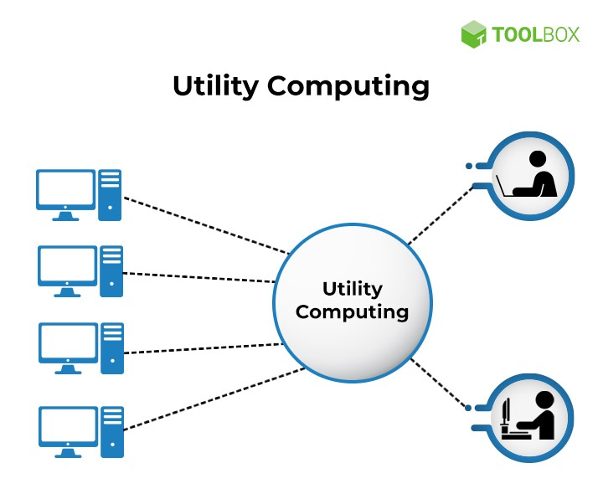

**Types Of Workload Pattern For The Cloud**

In cloud computing, workload patterns are a way to categorize the types of workloads that are commonly found in cloud environments. Here are some of the common workload patterns:

1. Bursty workloads: These are workloads that have spikes in demand, where resources are required for a short amount of time. Examples of bursty workloads include seasonal sales, promotional events, and social media campaigns.
2. Predictable workloads: These are workloads that have a consistent level of demand over time. Examples of predictable workloads include email and file storage services.
3. Continuous workloads: These are workloads that require a consistent level of resources over a long period of time. Examples of continuous workloads include web applications and databases.
4. Batch processing workloads: These are workloads that require a large amount of processing power for a short amount of time, such as running complex analytics or simulations.
5. High-performance computing workloads: These are workloads that require a large amount of processing power and memory, such as scientific simulations or rendering large images.

By understanding the different types of workload patterns, cloud providers can better design their infrastructure and pricing models to meet the needs of their customers.

**IT as a service in cloud computing**

IT as a Service (ITaaS) is a model of providing IT services to businesses through a cloud computing platform. In this model, a third-party provider delivers IT services to the business, who then pays for those services on a subscription or usage basis.

Cloud computing provides a flexible and scalable platform for ITaaS, allowing businesses to easily access and scale IT services to meet their needs. The cloud provider typically offers a range of IT services, such as computing, storage, networking, and security, which can be accessed through a web-based interface or API.

One of the main benefits of ITaaS in cloud computing is that it enables businesses to focus on their core operations without worrying about managing their IT infrastructure. The cloud provider takes care of all the hardware, software, and maintenance, allowing businesses to reduce their IT costs and free up resources for other initiatives. Additionally, ITaaS can be easily scaled up or down depending on the business's needs, allowing for greater flexibility and agility.

However, there are also some potential drawbacks to ITaaS in cloud computing, such as security concerns, data privacy issues, and the risk of vendor lock-in. Businesses need to carefully evaluate their options and choose a cloud provider that offers the right level of security, compliance, and data protection for their needs. They also need to ensure that they have the flexibility to switch providers if necessary, without incurring significant costs or disruption to their operations.

Example :-

There are many examples of ITaaS in cloud computing, as there are many cloud providers that offer a range of IT services to businesses. Here are a few examples:

1. Amazon Web Services (AWS): AWS is a popular cloud provider that offers a range of IT services, including computing, storage, databases, analytics, machine learning, and more. Businesses can use AWS to quickly provision IT resources, scale up or down as needed, and only pay for what they use.
2. Microsoft Azure: Azure is another major cloud provider that offers a range of IT services, including virtual machines, storage, databases, analytics, and more. Businesses can use Azure to deploy and manage applications and services in the cloud, and take advantage of Microsoft's expertise in enterprise software and services.
3. Google Cloud Platform (GCP): GCP is a cloud provider that offers a range of IT services, including computing, storage, networking, machine learning, and more. Businesses can use GCP to build and run applications and services in the cloud, and take advantage of Google's expertise in data and analytics.
4. Salesforce: Salesforce is a cloud-based platform that offers a range of IT services, including customer relationship management (CRM), marketing automation, e-commerce, and more. Businesses can use Salesforce to manage their customer relationships and sales processes, and take advantage of the platform's built-in analytics and automation capabilities.

These are just a few examples of ITaaS in cloud computing, and there are many other cloud providers and services available to businesses.Top of Form

# **Cloud Computing Applications**

Cloud service providers provide various applications in the field of art, business, data storage and backup services, education, entertainment, management, social networking, etc.

The most widely used cloud computing applications are given below -

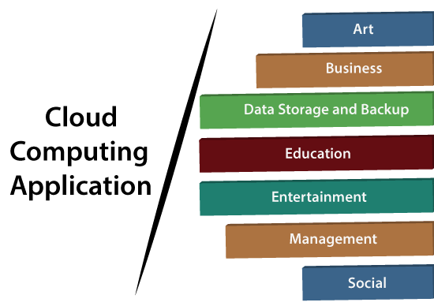

## . Art Applications

Cloud computing offers various art applications for quickly and easily design **attractive cards, booklets,** and **images**. Some most commonly used cloud art applications are given below:

**i Moo**

Moo is one of the best cloud art applications. It is used for designing and printing business cards, postcards, and mini cards.

**ii. Vistaprint**

## 2. Business Applications

Business applications are based on cloud service providers. Today, every organization requires the cloud business application to grow their business. It also ensures that business applications are 24*7 available to users.

There are the following business applications of cloud computing -

**i. MailChimp**

MailChimp is an **email publishing platform** which provides various options to **design, send,** and **save** templates for emails.

**iii. Salesforce**

## 3. Data Storage and Backup Applications

Cloud computing allows us to store information (data, files, images, audios, and videos) on the cloud and access this information using an internet connection. As the cloud provider is responsible for providing security, so they offer various backup recovery application for retrieving the lost data.

A list of data storage and backup applications in the cloud are given below -

Ex:-

**Joukuu , Google G Suite.**

## 4. Education Applications

Cloud computing in the education sector becomes very popular. It offers various **online distance learning platforms** and **student information portals** to the students. The advantage of using cloud in the field of education is that it offers strong virtual classroom environments, Ease of accessibility, secure data storage, scalability, greater reach for the students, and minimal hardware requirements for the applications.

There are the following education applications offered by the cloud -

**i. Google Apps for Education**

**ii. Chromebooks for Education**

**iii. AWS in Education**

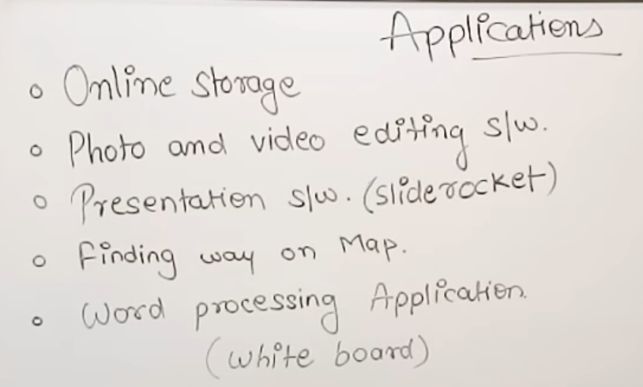

**UNIT – II**

**Virtualization Technique**

# **Virtualization in Cloud Computing**

**Virtualization** is the "creation of a virtual (rather than actual) version of something, such as a server, a desktop, a storage device, an operating system or network resources".

In other words, Virtualization is a technique, which allows to share a single physical instance of a resource or an application among multiple customers and organizations. It does by assigning a logical name to a physical storage and providing a pointer to that physical resource when demanded.

## What is the concept behind the Virtualization?

Creation of a virtual machine over existing operating system and hardware is known as Hardware Virtualization. A Virtual machine provides an environment that is logically separated from the underlying hardware.

The machine on which the virtual machine is going to create is known as **Host Machine** and that virtual machine is referred as a **Guest Machine**

## Types of Virtualization:

1. Hardware Virtualization.
2. Operating system Virtualization.
3. Server Virtualization.
4. Storage Virtualization.

### **1) Hardware Virtualization:**

When the virtual machine software or virtual machine manager *(VMM) is directly installed on the hardware system* is known as hardware virtualization.

The main job of hypervisor is to control and monitoring the processor, memory and other hardware resources.

After virtualization of hardware system we can install different operating system on it and run different applications on those OS.

**Usage:**

Hardware virtualization is mainly done for the server platforms, because controlling virtual machines is much easier than controlling a physical server.

### **2) Operating System Virtualization:**

When the virtual machine software or virtual machine manager *(VMM) is installed on the Host operating system* instead of directly on the hardware system is known as operating system virtualization.

**Usage:**

Operating System Virtualization is mainly used for testing the applications on different platforms of OS.

### **3) Server Virtualization:**

When the virtual machine software or virtual machine manager *(VMM) is directly installed on the Server system* is known as server virtualization.

**Usage:**

Server virtualization is done because a single physical server can be divided into multiple servers on the demand basis and for balancing the load.

### **4) Storage Virtualization:**

Storage virtualization is the *process of grouping the physical storage from multiple network storage devices so that it looks like a single storage device*.

Storage virtualization is also implemented by using software applications.

**Usage:**

Storage virtualization is mainly done for back-up and recovery purposes.

## How does virtualization work in cloud computing?

**Virtualization** plays a very important role in the cloud computing technology, normally in the cloud computing, users share the data present in the clouds like application etc, but actually with the help of virtualization users shares the Infrastructure.

The **main usage of Virtualization Technology** is to provide the applications with the standard versions to their cloud users, suppose if the next version of that application is released, then cloud provider has to provide the latest version to their cloud users and practically it is possible because it is more expensive.

To overcome this problem we use basically virtualization technology, By using virtualization, all severs and the software application which are required by other cloud providers are maintained by the third party people, and the cloud providers has to pay the money on monthly or annual basis.

**Characteristics Of Visualization**

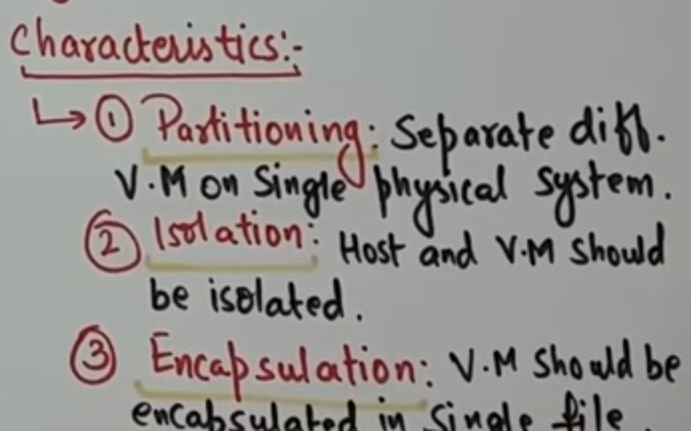

**Pros And Cons**

Virtualization is the process of creating a virtual version of an operating system, server, storage device, or network resources. It has become increasingly popular in recent years due to the many benefits it provides, but there are also some drawbacks to consider. Here are some pros and cons of virtualization:

**Pros:**

Cost-effective: Virtualization allows multiple virtual machines to run on a single physical server, reducing the need for expensive hardware and saving money on electricity bills.

Scalability: Virtualization allows resources to be allocated dynamically to meet changing demand, making it easy to scale up or down as needed.

Flexibility: Virtualization makes it easy to test and deploy new applications, as virtual machines can be easily created and destroyed.

Disaster recovery: Virtualization allows for quick and easy backup and restoration of virtual machines, making disaster recovery faster and more efficient.

Security: Virtualization provides an added layer of security by isolating virtual machines from each other and the host system.

**Cons:**

Performance overhead: Virtualization can impose performance overhead, as the virtualization layer adds an extra layer of processing that can cause some slowdown.

Complexity: Virtualization can be complex to set up and manage, requiring specialized knowledge and skills.

Single point of failure: Virtualization creates a single point of failure, as multiple virtual machines are running on a single physical server. If the host system fails, all of the virtual machines running on it will also fail.

Licensing: Virtualization can complicate licensing agreements for software and operating systems, as some vendors may require additional licensing fees for virtual machines.

Compatibility issues: Some hardware and software may not be compatible with virtualization, making it difficult to run certain applications or devices.

**Hypervisors**

A hypervisor is a software layer that allows multiple virtual machines (VMs) to run on a single physical machine. In cloud computing, hypervisors are used to create and manage virtualized infrastructure on which customers can deploy their applications and services.

Hypervisors are often classified into two types: Type 1 hypervisors, also known as bare-metal hypervisors, run directly on the host's hardware and are designed to manage the virtualization of the host's resources. Type 2 hypervisors, on the other hand, run on top of an operating system and provide virtualization capabilities through that OS.

In cloud computing, hypervisors are used to create virtualized instances of compute, storage, and network resources that can be allocated to customers on demand. These virtualized resources can be easily scaled up or down as needed, and customers only pay for the resources they actually use.

Hypervisors also provide isolation between different virtual machines, ensuring that customers' applications and services remain secure and don't interfere with each other. They also allow for easy migration of VMs between physical machines, enabling cloud providers to perform maintenance or upgrades without causing downtime for customers.

**Type Of Hypervisor**

There are two main types of hypervisors:

Type 1 or native or bare-metal hypervisor: This type of hypervisor runs directly on the host machine's hardware and provides direct access to the underlying hardware resources. It does not require an operating system to be installed on the host machine and is generally used in enterprise environments for server virtualization. Examples of type 1 hypervisors include VMware ESXi, Microsoft Hyper-V, and Citrix XenServer.

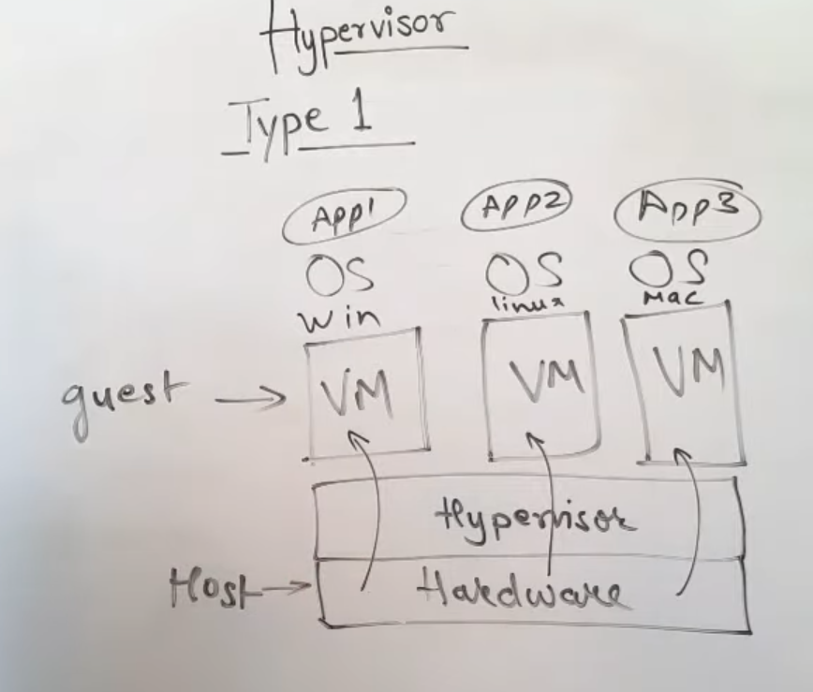

Type 2 or hosted hypervisor: This type of hypervisor runs on top of an operating system and is typically used for desktop virtualization. It relies on the host operating system to manage hardware resources and provide services to the virtual machines. Examples of type 2 hypervisors include Oracle VirtualBox, VMware Workstation, and Parallels Desktop for Mac.

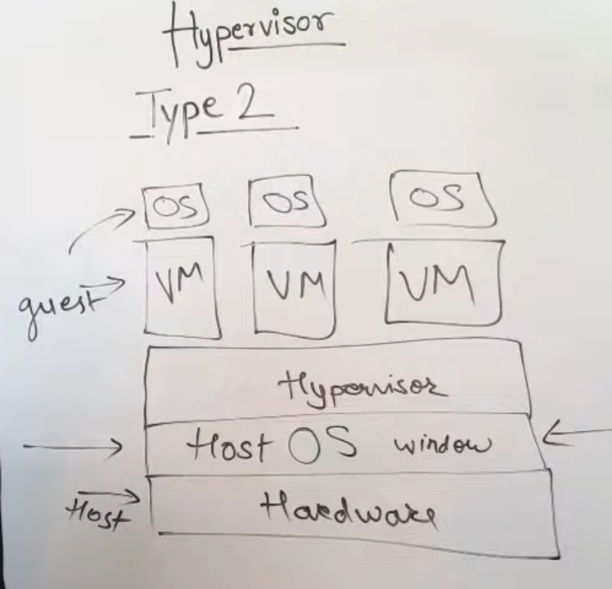

**Multitenecy**

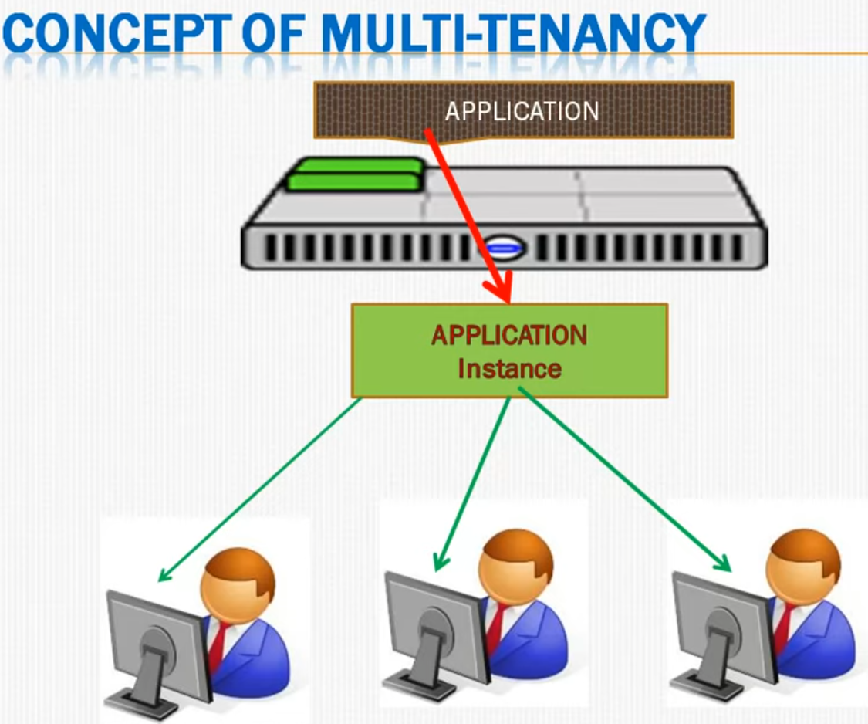

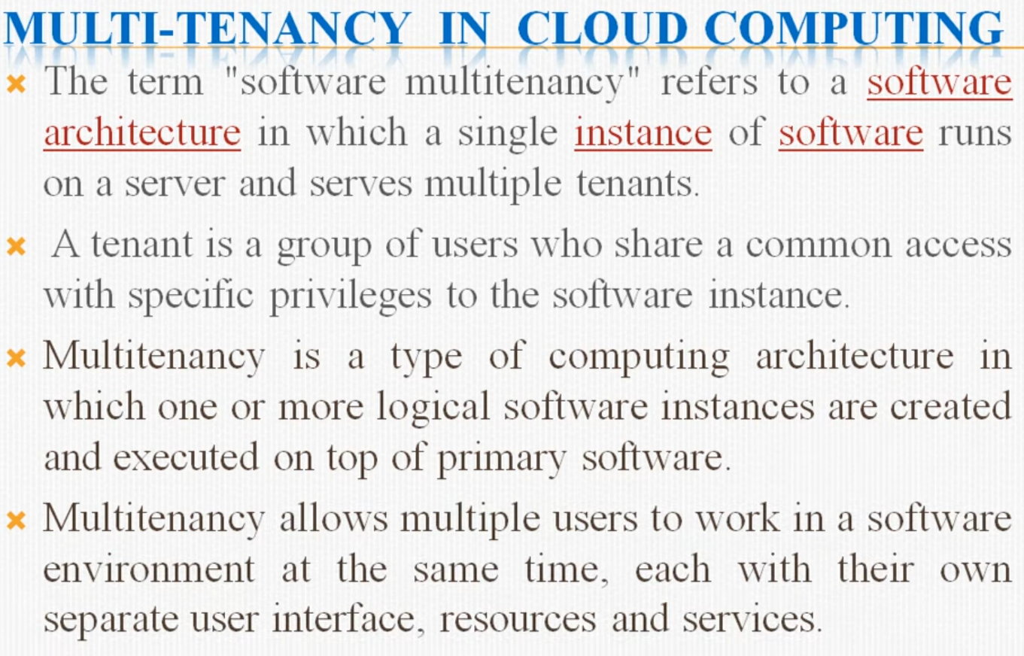

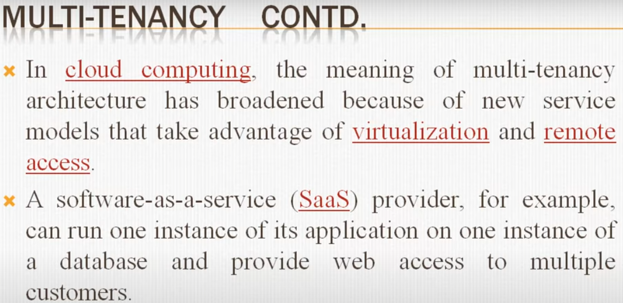

**API**

API stands for Application Programming Interface. It is a set of protocols, routines, and tools that allow different software applications to communicate and share information with each other. APIs define how software components should interact, and they enable developers to create software applications that can interact with other applications and services.

APIs can be used for a variety of purposes, such as integrating different software systems, accessing data from web services, automating tasks, and creating new applications. They are commonly used in web development, mobile app development, and cloud computing.

APIs can be created for different types of software, such as web applications, mobile applications, operating systems, databases, and hardware devices. They can be accessed through different protocols, such as HTTP, REST, SOAP, and others.

APIs are essential in modern software development because they allow developers to build complex systems by integrating existing software components. By using APIs, developers can save time and resources, and create more powerful and flexible applications.

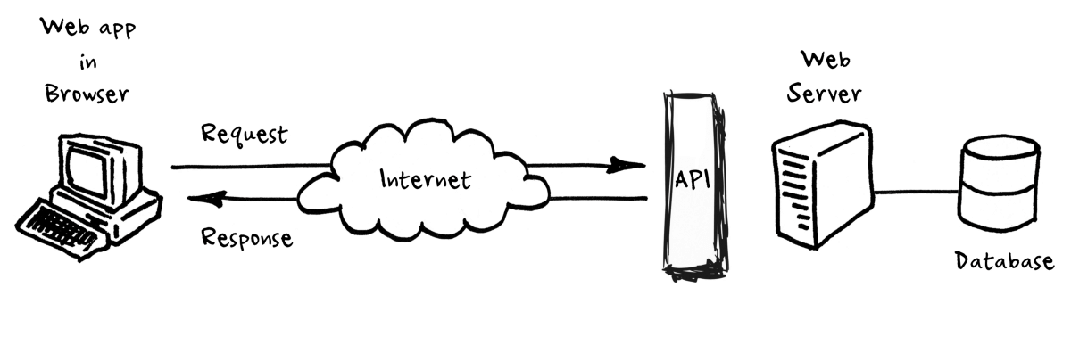





**Elasticity and Scalability**

Elasticity and scalability are two key concepts in cloud computing that allow resources to be provisioned and utilized dynamically, based on the changing needs of the application or service being hosted in the cloud.

Scalability refers to the ability of a system or application to handle an increasing workload by adding resources such as compute, storage, or networking. In cloud computing, scalability is achieved through horizontal scaling and Vertical scaling, where additional resources are added to the system by adding more virtual machines or containers. This allows the system to handle increased traffic and workload without affecting performance.

Elasticity, on the other hand, refers to the ability of a system or application to dynamically scale up or down resources in response to changing demands. In cloud computing, elasticity is achieved through a combination of automation and monitoring tools that can automatically provision or deprovision resources based on predefined thresholds or rules. This means that resources can be added or removed as needed, without any manual intervention.

In summary, scalability allows a system or application to handle an increasing workload by adding more resources, while elasticity enables resources to be added or removed automatically, based on the changing needs of the system or application. Together, these concepts allow cloud computing systems to be highly adaptable and responsive to changing demands, making them an ideal platform for hosting modern applications and services.

**UNIT – III**

**Cloud Service**

Cloud computing is the delivery of computing services, including servers, storage, databases, networking, software, analytics, and intelligence, over the Internet ("the cloud"). Cloud computing offers businesses and individuals a cost-effective and scalable solution for their computing needs.

# **Cloud Service Models**

There are the following three types of cloud service models -

1. [Infrastructure as a Service (IaaS)](https://www.javatpoint.com/cloud-service-models#IaaS)
2. [Platform as a Service (PaaS)](https://www.javatpoint.com/cloud-service-models#PaaS)
3. [Software as a Service (SaaS)](https://www.javatpoint.com/cloud-service-models#SaaS)

## Infrastructure as a Service (IaaS)

IaaS is also known as **Hardware as a Service (HaaS)**. It is a computing infrastructure managed over the internet. The main advantage of using IaaS is that it helps users to avoid the cost and complexity of purchasing and managing the physical servers.

### **Characteristics of IaaS**

There are the following characteristics of IaaS -

* Resources are available as a service
* Services are highly scalable
* Dynamic and flexible
* GUI and API-based access
* Automated administrative tasks

**Example:** DigitalOcean, Linode, Amazon Web Services (AWS), Microsoft Azure, Google Compute Engine (GCE), Rackspace, and Cisco Metacloud.

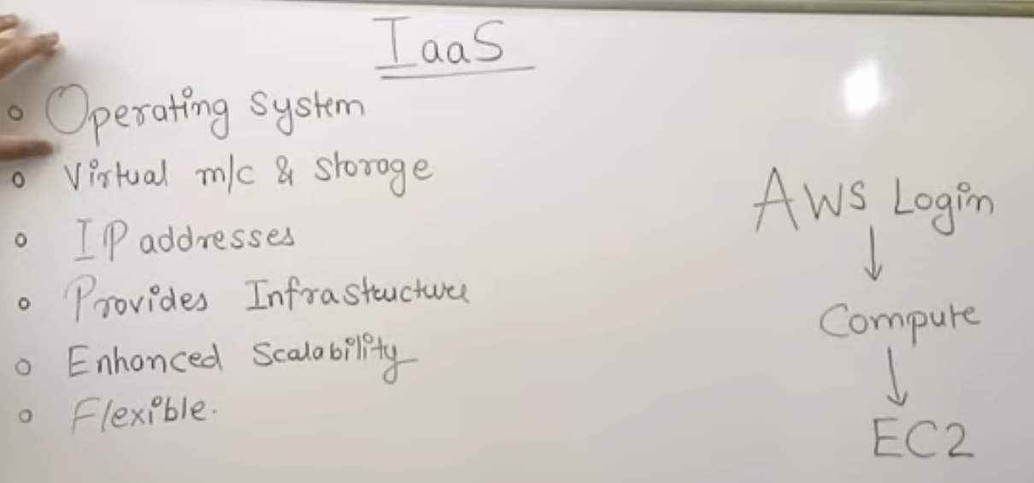

## Architecture of Infrastructure as a Service (IaaS)

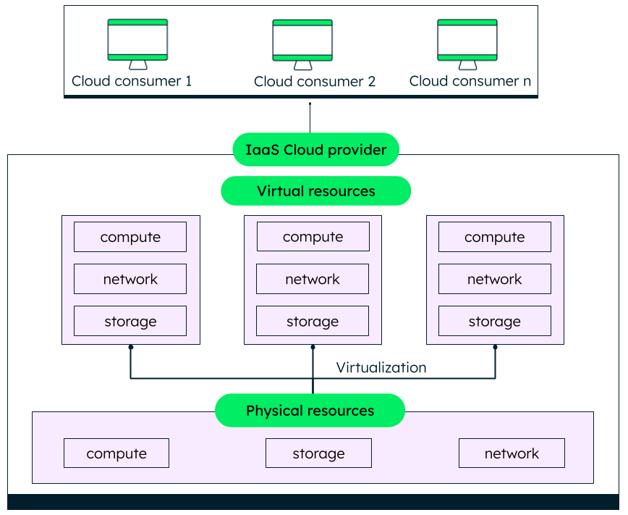

# **Software as a Service(SaaS)**

Software-as-a-Service (SaaS) is a web-based software application delivered to the end-users through the internet. Instead of installing and maintaining software on the device, SaaS offers a subscription-based model where users can easily access the entire application and its IT infrastructure. SaaS providers maintain application servers, database layers, and code base that makes up the entire application.

SaaS is also known as "**On-Demand Software**". It is a software distribution model in which services are hosted by a cloud service provider. These services are available to end-users over the internet so, the end-users do not need to install any software on their devices to access these services.

There are the following services provided by SaaS providers -

**Business Services** - SaaS Provider provides various business services to start-up the business. The SaaS business services include **ERP** (Enterprise Resource Planning), **CRM** (Customer Relationship Management), **billing**, and **sales**.

**Document Management** - SaaS document management is a software application offered by a third party (SaaS providers) to create, manage, and track electronic documents.

**Example:** Slack, Samepage, Box, and Zoho Forms.

**Social Networks** - As we all know, social networking sites are used by the general public, so social networking service providers use SaaS for their convenience and handle the general public's information.

**Mail Services** - To handle the unpredictable number of users and load on e-mail services, many e-mail providers offering their services using SaaS.

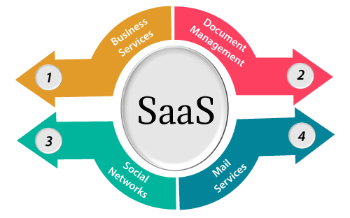

## Advantages of SaaS cloud computing layer

**1) SaaS is easy to buy**

SaaS pricing is based on a monthly fee or annual fee subscription, so it allows organizations to access business functionality at a low cost, which is less than licensed applications.

Unlike traditional software, which is sold as a licensed based with an up-front cost (and often an optional ongoing support fee), SaaS providers are generally pricing the applications using a subscription fee, most commonly a monthly or annually fee.

**2. One to Many**

SaaS services are offered as a one-to-many model means a single instance of the application is shared by multiple users.

**3. Less hardware required for SaaS**

The software is hosted remotely, so organizations do not need to invest in additional hardware.

**4.Multidevice support**

SaaS services can be accessed from any device such as desktops, laptops, tablets, phones, and thin clients.

## Disadvantages of SaaS cloud computing layer

**1) Security**

Actually, data is stored in the cloud, so security may be an issue for some users. However, cloud computing is not more secure than in-house deployment.

**2) Total Dependency on Internet**

Without an internet connection, most SaaS applications are not usable.

## Popular SaaS Providers

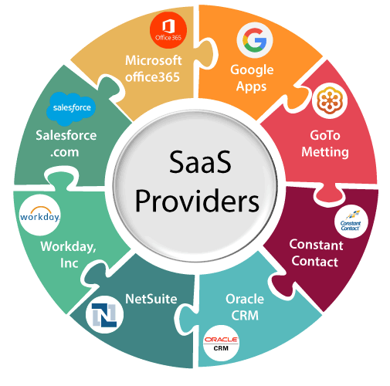

## Architecture of Software as a Service (SaaS)

## SaaS Architecture Simform

## Platform as a Service (PaaS)

Platform as a Service (PaaS) provides a runtime environment. It allows programmers to easily create, test, run, and deploy web applications. You can purchase these applications from a cloud service provider on a pay-as-per use basis and access them using the Internet connection. In PaaS, back end scalability is managed by the cloud service provider, so end- users do not need to worry about managing the infrastructure.

PaaS includes infrastructure (servers, storage, and networking) and platform (middleware, development tools, database management systems, business intelligence, and more) to support the web application life cycle.

**Example:** Google App Engine, Force.com, Joyent, Azure.

## PaaS providers provide the Programming languages, Application frameworks, Databases, and Other tools:

### **1. Programming languages**

PaaS providers provide various programming languages for the developers to develop the applications. Some popular programming languages provided by PaaS providers are Java, PHP, Ruby, Perl, and Go.

### **2. Application frameworks**

PaaS providers provide application frameworks to easily understand the application development. Some popular application frameworks provided by PaaS providers are Node.js, Drupal, Joomla, WordPress, Spring, Play, Rack, and Zend.

### **3. Databases**

PaaS providers provide various databases such as ClearDB, PostgreSQL, MongoDB, and Redis to communicate with the applications.

## Advantages of PaaS

There are the following advantages of PaaS -

**1) Simplified Development**

PaaS allows developers to focus on development and innovation without worrying about infrastructure management.

**2) Lower risk**

No need for up-front investment in hardware and software. Developers only need a PC and an internet connection to start building applications.

## Disadvantages of PaaS cloud computing layer

**1) Vendor lock-in**

One has to write the applications according to the platform provided by the PaaS vendor, so the migration of an application to another PaaS vendor would be a problem.

**2) Data Privacy**

Corporate data, whether it can be critical or not, will be private, so if it is not located within the walls of the company, there can be a risk in terms of privacy of data.

## Popular PaaS Providers

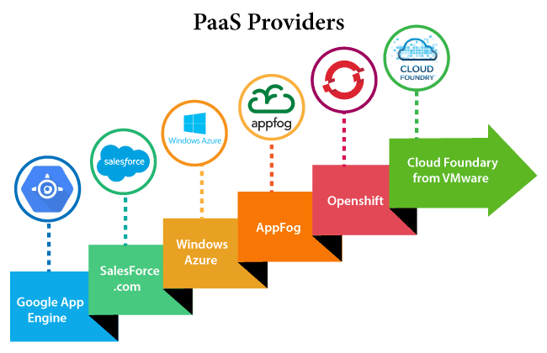

## Architecture of Platform as a Service (PaaS)

## What is PaaS (Platform as a Service) in Cloud Computing? | Benefits of PaaS - MilesWeb

**UNIT – VI**

### **What Is A Cloud Deployment Model**

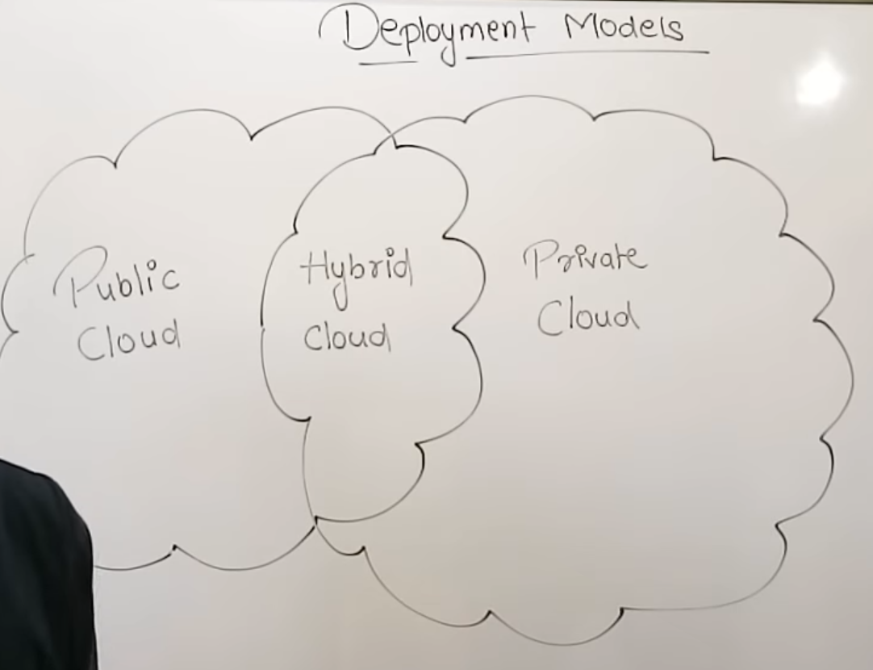

It works as your virtual computing environment with a choice of deployment model depending on how much data you want to store and who has access to the Infrastructure.

### **Different Types Of Cloud Computing Deployment Models**

Most cloud hubs have tens of thousands of servers and storage devices to enable fast loading. It is often possible to choose a geographic area to put the data "closer" to users. Thus, deployment models for cloud computing are categorized based on their location. To know which model would best fit the requirements of your organization, let us first learn about the various types.

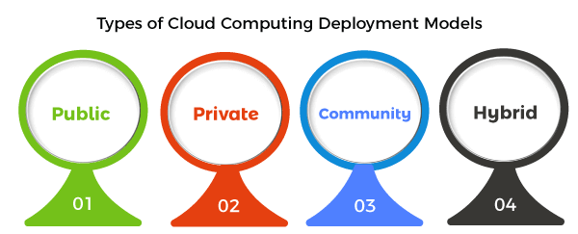

### **Public Cloud**

The name says it all. It is accessible to the public. Public deployment models in the cloud are perfect for organizations with growing and fluctuating demands. It also makes a great choice for companies with low-security concerns. Thus, you pay a cloud service provider for networking services, compute virtualization & storage available on the public internet. It is also a great delivery model for the teams with development and testing. Its configuration and deployment are quick and easy, making it an ideal choice for test environments.

**Benefits of Public Cloud**

* Minimal Investment - As a pay-per-use service, there is no large upfront cost and is ideal for businesses who need quick access to resources
* No Hardware Setup - The cloud service providers fully fund the entire Infrastructure
* No Infrastructure Management - This does not require an in-house team to utilize the public cloud.

**Limitations of Public Cloud**

* Data Security and Privacy Concerns - Since it is accessible to all, it does not fully protect against cyber-attacks and could lead to vulnerabilities.
* Reliability Issues - Since the same server network is open to a wide range of users, it can lead to malfunction and outages
* Service/License Limitation - While there are many resources you can exchange with tenants, there is a usage cap.

### **Private Cloud**

Now that you understand what the public cloud could offer you, of course, you are keen to know what a private cloud can do. Companies that look for cost efficiency and greater control over data & resources will find the private cloud a more suitable choice.

It means that it will be integrated with your data center and managed by your IT team. Alternatively, you can also choose to host it externally. The private cloud offers bigger opportunities that help meet specific organizations' requirements when it comes to customization. It's also a wise choice for mission-critical processes that may have frequently changing requirements.

**Benefits of Private Cloud**

* Data Privacy - It is ideal for storing corporate data where only authorized personnel gets access
* Security - Segmentation of resources within the same Infrastructure can help with better access and higher levels of security.
* Supports Legacy Systems - This model supports legacy systems that cannot access the public cloud.

**Limitations of Private Cloud**

* Higher Cost - With the benefits you get, the investment will also be larger than the public cloud. Here, you will pay for software, hardware, and resources for staff and training.
* Fixed Scalability - The hardware you choose will accordingly help you scale in a certain direction
* High Maintenance - Since it is managed in-house, the maintenance costs also increase.

### **Community Cloud**

The community cloud operates in a way that is similar to the public cloud. There's just one difference - it allows access to only a specific set of users who share common objectives and use cases. This type of deployment model of cloud computing is managed and hosted internally or by a third-party vendor. However, you can also choose a combination of all three.

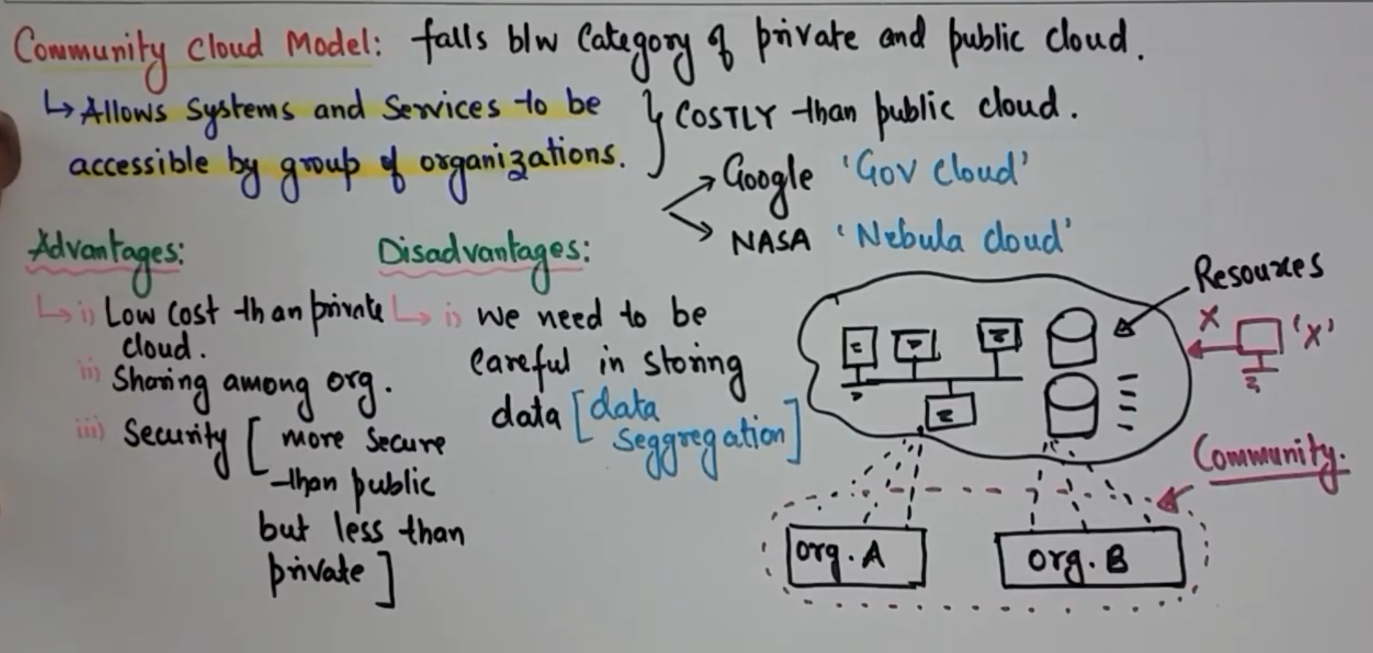

**Benefits of Community Cloud**

* Smaller Investment - A community cloud is much cheaper than the private & public cloud and provides great performance
* Setup Benefits - The protocols and configuration of a community cloud must align with industry standards, allowing customers to work much more efficiently.

**Limitations of Community Cloud**

* Shared Resources - Due to restricted bandwidth and storage capacity, community resources often pose challenges.
* Not as Popular - Since this is a recently introduced model, it is not that popular or available across industries

### **Hybrid Cloud**

As the name suggests, a hybrid cloud is a combination of two or more cloud architectures. While each model in the hybrid cloud functions differently, it is all part of the same architecture. Further, as part of this deployment of the cloud computing model, the internal or external providers can offer resources.

Let's understand the hybrid model better. A company with critical data will prefer storing on a private cloud, while less sensitive data can be stored on a public cloud. The hybrid cloud is also frequently used for 'cloud bursting'. It means, supposes an organization runs an application on-premises, but due to heavy load, it can burst into the public cloud.

**Benefits of Hybrid Cloud**

* Cost-Effectiveness - The overall cost of a hybrid solution decreases since it majorly uses the public cloud to store data.
* Security - Since data is properly segmented, the chances of data theft from attackers are significantly reduced.
* Flexibility - With higher levels of flexibility, businesses can create custom solutions that fit their exact requirements

**Limitations of Hybrid Cloud**

* Complexity - It is complex setting up a hybrid cloud since it needs to integrate two or more cloud architectures
* Specific Use Case - This model makes more sense for organizations that have multiple use cases or need to separate critical and sensitive data

**Migration Paths For Cloud**

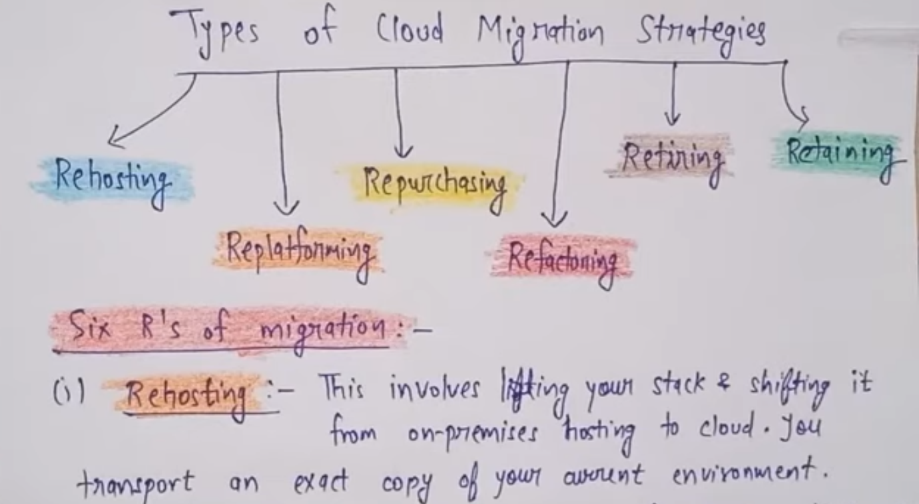

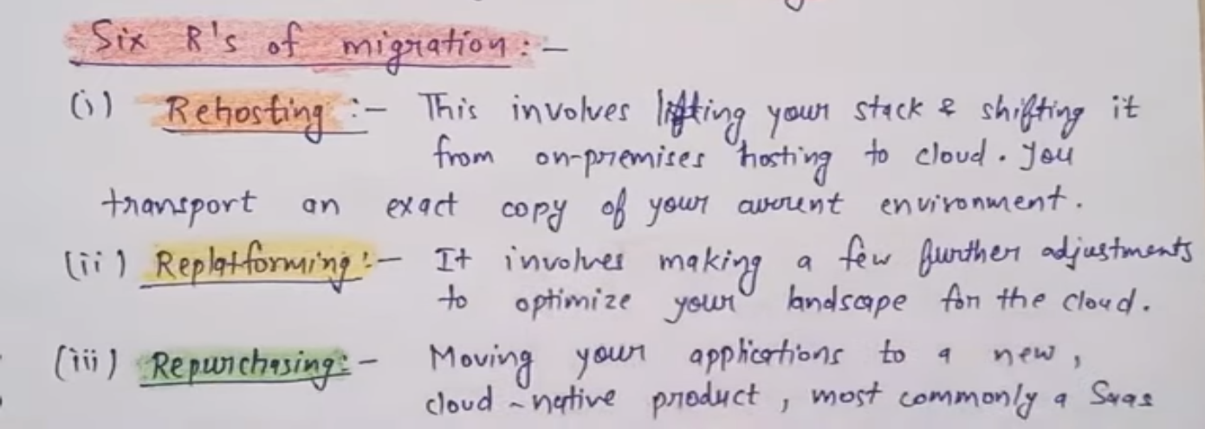

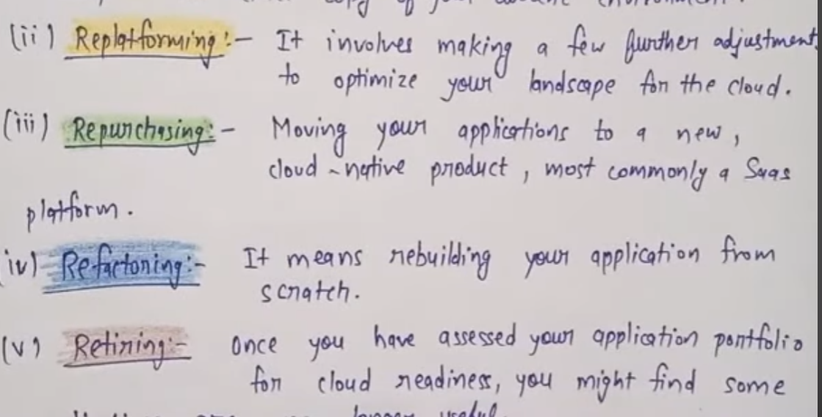

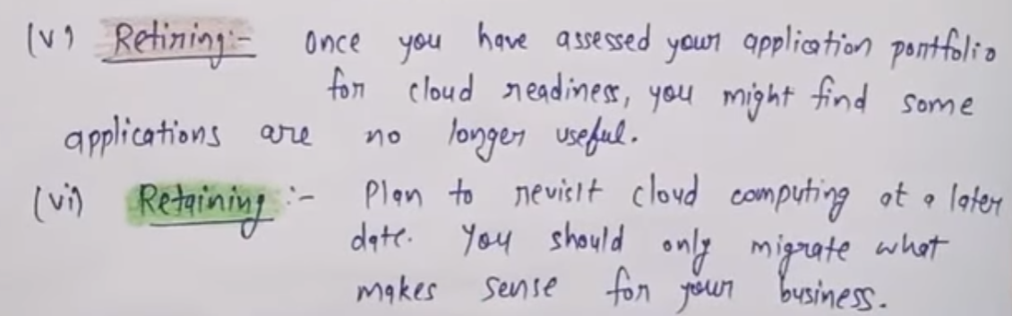

**Selection Criteria For Cloud Deployment**

# **8 CRITERIA TO ENSURE YOU SELECT THE RIGHT CLOUD SERVICE PROVIDER**

When it comes to selecting a cloud provider, the requirements you have and evaluation criteria you use will be unique to your organisation. However, there are some common areas of focus during any service provider assessment.

We have grouped these into 8 sections to help you effectively compare suppliers and select a provider that delivers the value and benefits your organisation expects from the cloud.

1. Certifications & Standards
2. Technologies & Service Roadmap
3. Data Security, Data Governance and Business policies
4. Service Dependencies & Partnerships
5. Contracts, Commercials & SLAs
6. Reliability & Performance
7. Migration Support, Vendor Lock in & Exit Planning
8. Business health & Company profile

### **CERTIFICATIONS & STANDARDS:-**

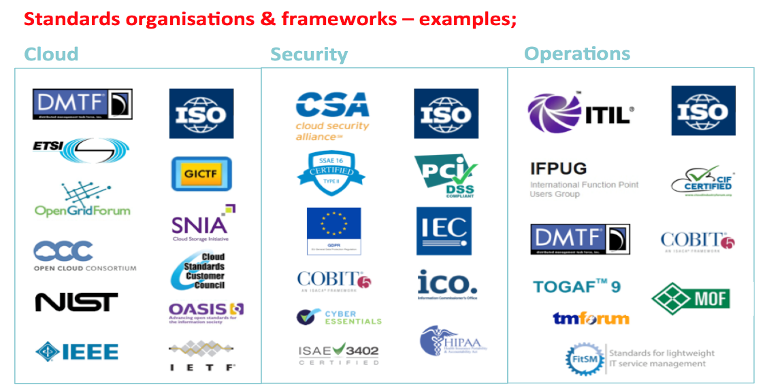Providers that comply with recognised standards and quality frameworks demonstrate an adherence to industry best practices and standards. While standards may not determine which service provider you choose, they can be very helpful in shortlisting potential suppliers.

### **TECHNOLOGIES & SERVICE ROADMAP**

#### **Technologies**

Make sure the provider’s platform and preferred technologies align with your current environment and/or support your cloud objectives.

#### **Service roadmap**

Ask about the provider’s roadmap of service development – How do they plan to continue to innovate and grow over time? Does their roadmap fit your needs in the long term?

Important factors to consider are commitments to specific technologies or vendors, and how interoperability is supported. Also can they demonstrate similar deployments to the ones you are planning

### **DATA GOVERNANCE AND SECURITY**

#### **Data management**

You may already have a data classification scheme in place that defines types of data according to sensitivity and/or policies on data residency. At the very least you should be aware of regulatory or data privacy rules governing personal data.

### **SERVICE DEPENDENCIES & PARTNERSHIPS**

#### **Vendor relationships**

Service providers may have multiple vendor relationships that are important to understand.

Assessing the provider’s relationship with key vendors, their accreditation levels, technical capabilities and staff certifications, is a worthwhile exercise. Do they support multivendor environments and can they give good examples.

### **CONTRACTS, COMMERCIALS & SLAS**

#### **Contracts & SLAs**

Cloud agreements can appear complex, and this isn’t helped by a lack of industry standards for how they are constructed and defined. For SLAs in particular, many jargon-happy cloud providers are still using unnecessarily complicated, or worse, deliberately misleading language

### **RELIABILITY & PERFORMANCE**

There are several methods you can use to measure the reliability of a service provider.

First, check the performance of the service provider against their SLAs for the last 6-12 months.  Some service providers publish this information, but others should supply it if asked.

### **MIGRATION SUPPORT, VENDOR LOCK IN & EXIT PLANNING**

Vendor lock-in, is a situation in which a customer using a product or service cannot easily transition to a competitor. Vendor lock-in is usually the result of proprietary technologies that are incompatible with those of competitors. However, it can also be caused by inefficient processes, or contract constraints, among other things.

### **BUSINESS HEALTH & COMPANY PROFILE**

Assessing the technical and operational capabilities of a potential supplier is obviously important, but take time to consider the financial health and profile of your shortlisted providers.

### **SUMMARY**

Include hard and soft factors in your assessment of prospective providers: recognise and validate both the certifications and standards they adhere to, but also what their customers say about them in case studies and testimonials.

**UNIT - V**

# **What are the Security Risks of Cloud Computing**

Cloud computing provides various advantages, such as improved collaboration, excellent accessibility, Mobility, Storage capacity, etc. But there are also security risks in cloud computing.

Some most common Security Risks of Cloud Computing are given below-

### **Data Loss**

Data loss is the most common cloud security risks of cloud computing. It is also known as data leakage. Data loss is the process in which data is being deleted, corrupted, and unreadable by a user, software, or application. In a cloud computing environment, data loss occurs when our sensitive data is somebody else's hands, one or more data elements can not be utilized by the data owner, hard disk is not working properly, and software is not updated.

### **Hacked Interfaces and Insecure APIs**

As we all know, cloud computing is completely depends on Internet, so it is compulsory to protect interfaces and APIs that are used by external users. APIs are the easiest way to communicate with most of the cloud services. In cloud computing, few services are available in the public domain. These services can be accessed by third parties, so there may be a chance that these services easily harmed and hacked by hackers.

### **Data Breach**

Data Breach is the process in which the confidential data is viewed, accessed, or stolen by the third party without any authorization, so organization's data is hacked by the hackers.

### **Vendor lock-in**

Vendor lock-in is the of the biggest security risks in cloud computing. Organizations may face problems when transferring their services from one vendor to another. As different vendors provide different platforms, that can cause difficulty moving one cloud to another.

### **Increased complexity strains IT staff**

Migrating, integrating, and operating the cloud services is complex for the IT staff. IT staff must require the extra capability and skills to manage, integrate, and maintain the data to the cloud.

### **Spectre & Meltdown**

Spectre & Meltdown allows programs to view and steal data which is currently processed on computer. It can run on personal computers, mobile devices, and in the cloud. It can store the password, your personal information such as images, emails, and business documents in the memory of other running programs.

### **Denial of Service (DoS) attacks**

Denial of service (DoS) attacks occur when the system receives too much traffic to buffer the server. Mostly, DoS attackers target web servers of large organizations such as banking sectors, media companies, and government organizations. To recover the lost data, DoS attackers charge a great deal of time and money to handle the data.

### **Account hijacking**

Account hijacking is a serious security risk in cloud computing. It is the process in which individual user's or organization's cloud account (bank account, e-mail account, and social media account) is stolen by hackers. The hackers use the stolen account to perform unauthorized activities.

**Principal Security Dangers To Cloud Computing**

There are several principal security dangers to cloud computing, some of which include:

Data breaches: Cloud computing involves the storage and processing of sensitive data in third-party servers, making it Unsecure to data breaches(transfer) if adequate security measures are not put in place.

Insecure APIs: Application Programming Interfaces (APIs) are used to connect cloud services, and if they are not secured, they can be exploited by attackers to gain unauthorized access to data.

Insider threats: Cloud computing involves many people with varying levels of access to data, making it susceptible to insider threats such as malicious employees, contractors, or even partners.

Data loss: Data stored in the cloud can be lost due to accidents, disasters, or malicious attacks, leading to irreparable damage to a company's reputation, as well as financial losses.

Account hijacking: If cloud provider accounts are compromised, attackers can gain unauthorized access to the cloud services, leading to data breaches, theft, or destruction.

Malware infections: Malware can infect cloud resources and propagate within the network, leading to data loss, system outages, and other security issues.

Lack of visibility and control: Cloud computing involves the transfer of control over data and applications to a third-party provider, which can lead to a loss of visibility and control over the security of the data and applications.

Overall, it is important to implement robust security measures and monitor cloud resources continuously to prevent and detect security threats.

**Internal Security Breaches**

Internal security breaches in cloud computing refer to security incidents that are caused by insiders who have legitimate access to an organization's cloud resources, such as employees, contractors, or partners. These breaches can be intentional or accidental and can result in the unauthorized access, use, disclosure, modification, or destruction of sensitive data, applications, or infrastructure hosted in the cloud.

Some examples of internal security breaches in cloud computing include:

Insider theft: When an employee steals(Churana) sensitive data, intellectual property, or other confidential information from the organization's cloud infrastructure.

Misuse of privileges: When an employee or partner with high-level privileges uses their access to modify or delete data, change configurations, or gain unauthorized access to other parts of the system.

Human error: When an employee accidentally deletes important data, misconfigures security settings, or falls for a phishing attack, leading to a security breach.

Malware attacks: When an employee downloads malware onto the cloud infrastructure, either intentionally or unknowingly, which can lead to the theft of data or system disruption.

To prevent internal security breaches in cloud computing, organizations should implement strict access controls, regularly monitor and audit user activities, provide security awareness training to employees, and use advanced security tools such as data encryption, firewalls, and intrusion detection systems.

**User Account And Service Hijacking in Cloud Computing**

User account and service hijacking are important security concerns in cloud computing. Cloud computing is a distributed computing model that enables on-demand access to shared computing resources such as servers, storage, applications, and services over the internet. User account hijacking occurs when an attacker gains unauthorized access to a legitimate user's account, while service hijacking occurs when an attacker gains control of a cloud service.

User account hijacking can be done using a variety of methods such as phishing, password guessing, and exploiting vulnerabilities in authentication mechanisms. Once an attacker gains access to a user's account, they can perform various malicious activities such as stealing sensitive data, accessing confidential information, and using the account for unauthorized purposes.

Service hijacking occurs when an attacker gains unauthorized access to a cloud service or application. This can be achieved by exploiting vulnerabilities in the cloud service or application, or by stealing the access credentials of legitimate users. Once an attacker gains access to a cloud service, they can perform various malicious activities such as stealing data, modifying or deleting data, and disrupting service availability.

To mitigate the risk of user account and service hijacking in cloud computing, it is important to implement strong access controls and authentication mechanisms. This includes the use of strong passwords, two-factor authentication, and role-based access control. Regular security assessments and audits should also be conducted to identify and mitigate vulnerabilities in cloud services and applications. Additionally, it is important to educate users about the risks of phishing and other social engineering attacks.

# **8 Tricks to Prevent Security Breaches with Cloud Computing**

Cloud computing has opened up a whole new world of opportunities to the small and medium enterprises. It is cost-effective, scalable, convenient, and allows the users to collaborate with others in the most effective way possible. And most importantly, it allows you to store your crucial data on the cloud database which can be used from anywhere, anytime.

However, the security of the cloud database is a huge concern for the majority of the organizations. With all the security risks, threats and breaches, not just the stored data but even the cloud based applications require comprehensive security management. While there is a huge risk of a data breach in cloud networks, you can put an end to such breaches with some smart measures.

**Table of Contents**[](https://www.completeconnection.ca/prevent-security-breaches-with-cloud-computing/)

* [1. Authenticate the people who have access to the network:](https://www.completeconnection.ca/prevent-security-breaches-with-cloud-computing/#1_Authenticate_the_people_who_have_access_to_the_network)
* [2. Frame user-specific access permissions:](https://www.completeconnection.ca/prevent-security-breaches-with-cloud-computing/#2_Frame_user-specific_access_permissions)
* [3. Authenticate all the software that runs on the system:](https://www.completeconnection.ca/prevent-security-breaches-with-cloud-computing/#3_Authenticate_all_the_software_that_runs_on_the_system)
* [4. Keep a log of all the unusual activities:](https://www.completeconnection.ca/prevent-security-breaches-with-cloud-computing/#4_Keep_a_log_of_all_the_unusual_activities)
* [5. Streamline the permission requesting process:](https://www.completeconnection.ca/prevent-security-breaches-with-cloud-computing/#5_Streamline_the_permission_requesting_process)
* [6. Encrypt your data for an extra layer of security:](https://www.completeconnection.ca/prevent-security-breaches-with-cloud-computing/#6_Encrypt_your_data_for_an_extra_layer_of_security)
* [7. Monitor the user activities and analyze them for unexpected behavior:](https://www.completeconnection.ca/prevent-security-breaches-with-cloud-computing/#7_Monitor_the_user_activities_and_analyze_them_for_unexpected_behavior)

## ****1. Authenticate the people who have access to the network:****

Your data on the cloud is safe as you keep it. If you give your network access to every Tom, Dick and Harry, you are going to end up compromising your data security. It is wiser to authenticate the person whom you are giving access to your cloud database.

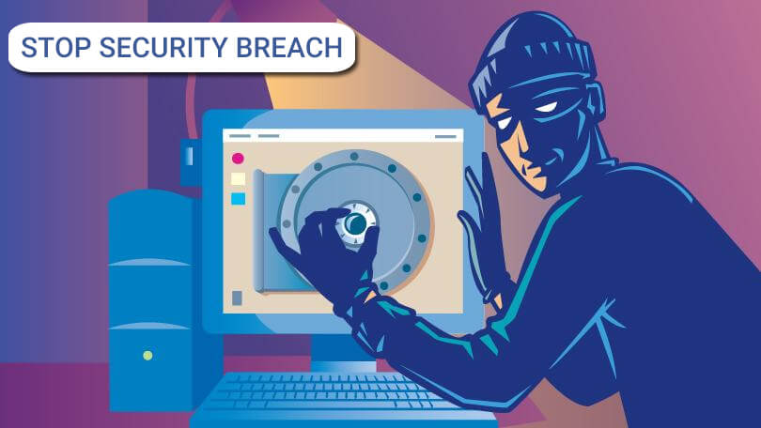

A proper authentication of each of the users will not only help you keep a tab on the access log for each user but also reduce the chances of unauthorized access. Whether you run cloud-based **free VAT software**or a premium accounting application, such authentication can save you from several security breaches.

## ****2. Frame user-specific access permissions:****

If you are responsible for the maintenance of the cloud database of the organization, quite obviously you don’t need to know what marketing strategy the organization is adopting for the next month’s campaign.

Similarly, there’s no need to give an all-access pass to the database to everyone in the organization. While issuing the network access to each of the individuals frame their access permission as per their job role. This may just help you reduce the data breach.

## ****3. Authenticate all the software that runs on the system:****

Whether you realize this or not, the software you or the other users in the organization used on the system can be responsible for the security breach in the cloud database. Since the software, especially the cloud-based ones, are run by the third party, you need to make each one of them carry no threat to your cloud database.

Get the software patches authenticated by the cloud providers. Also, manage the security patches with more firmness. You may be aware of the fact that a lot of service outages are caused by configuration errors.

## ****4. Keep a log of all the unusual activities:****

You need to be more watchful about the unusual activities that take place on the network. Most of the cloud service providers these days claim to provide with several layers of security. However, you need to ensure the safety of all the data that are stored in the cloud and the applications that are integrated into the cloud service.

Install an intruder-detection technology which will notify you every time there is suspicious activity in progress. This may help you prevent the security breach then and there while acknowledging the source of the breach.

## ****5. Streamline the permission requesting process:****

In order to make sure all the requests for permission to access the data or applications are proceeding properly, you need to streamline the process. Unless you formalize the requesting process, you leave a room for error which will be enough for the opportunists to breach the security of your network.

Whether you are sharing the system with a third party or you have given the access to the members of the organizations only, a streamlined requesting process will help you maintain a safe and secure network. In fact, you should include the permission to upload data to the cloud in this streamlining process.

## ****6. Encrypt your data for an extra layer of security:****

Encryption adds an extra layer of protection on the data by transforming it into something else. So, it is always better to keep the crucial data encrypted while uploading it to the cloud. Keep the keys to encrypt and decipher the information with you.

Since most of the cloud services are usually provided by the third party, it is always recommended to add some extra layer of protection on the data, just to be extra sure. Also, when you keep the keys to encrypt and decipher with you, no one will be able to make use of that data except you.

## ****7. Monitor the user activities and analyze them for unexpected behavior:****

Whether you are aware of it or not, the majority of the security breaches are done by someone inside the organization. Without any assistance from the inside, no outsider can breach the security and steal data from the network. However, the insiders rarely get caught.

Keeping a tab on the activities of the users can help you prevent the security breach to a great extent. Just monitor all the unexpected activities that are done by the members and follow them up regarding the issue.

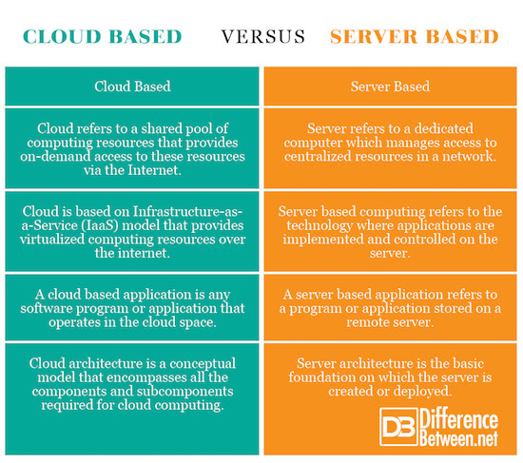**Comparison Between Cloud Platform And Web Services**